# Fix The Query

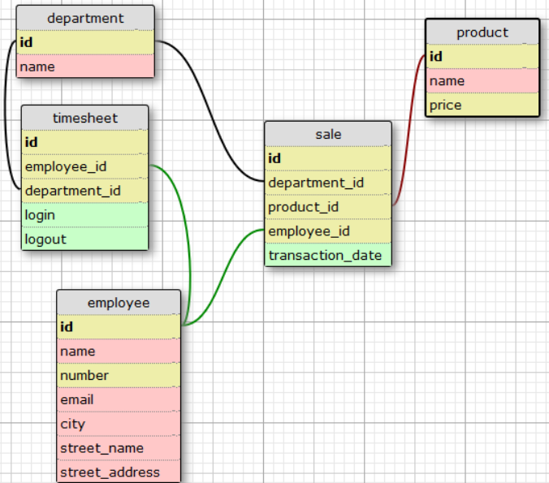

Resultant table:

* day (type: date) {group by} [order by asc]
* department (type: text) {group by} [In a real world situation it is bad practice to name a column after a table]
* sale_count (type: int)